Supply Chain Management (SCM) — NPTEL
Week 9 · Session 1: Intelligent Decision Tools — DC Location Problem & K-means Clustering (Intro)
1. Module 3 — Topics Covered So Far
Module 3: Analytics in SCM — Topics Covered
✓ What is Analytics
✓ Big Data & 6 V's (Volume, Variety, Velocity, Variability, Value, Veracity)
✓ Types of Analytics: Descriptive, Diagnostic, Predictive, Prescriptive
✓ Analytics examples from SCM domain
✓ AI & ML in Forecasting and Demand Analytics
✓ SC Network Optimization (Weeks 8)
→ Intelligent Decision Tool Development — K-means Clustering

- Today's new topic: Intelligent Decision Tool Development — using K-means Clustering for DC location

2. Case Study — Pharma Company Expansion
Background
- A pharmaceutical company wants to expand into a new region
- Has collected location data (latitude & longitude) of 811 prospective customers
- Example: Customer 1 → Lat: 27.72290, Long: 80.94479
- Example: Customer 811 → Lat: 27.51351, Long: 80.43675
Slno | Location | Latitude | Longitude
1 | Customer Location 1 | 27.72290 | 80.94479
2 | Customer Location 2 | 27.22984 | 80.93551
3 | Customer Location 3 | 27.46106 | 80.41345
4 | Customer Location 4 | 27.40798 | 80.99226
5 | Customer Location 5 | 27.53589 | 80.52644
6 | Customer Location 6 | 27.33868 | 81.22677
7 | Customer Location 7 | 27.65367 | 80.51901
... | ... | ... | ...
811 | Customer Location 811 | 27.51351 | 80.43675
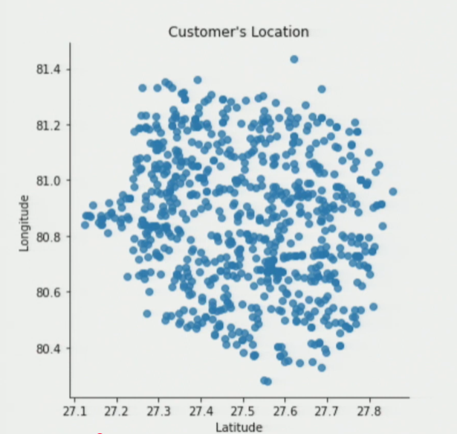
The Core Problem
- Need to decide: where to open Distribution Centers (DCs) to serve these 811 customers
- Data plotted: X-axis = latitude, Y-axis = longitude → all 811 locations visible on map
- Two key questions arise:

Decision 1 — Where to locate DCs? | Decision 2 — Which customers served by which DC?
How many DCs to open? | How to segment 811 customers across DCs?
At what coordinates (lat, long)? | Is there a systematic / optimal mapping?
Tradeoff: more DCs = better service but higher cost | Cannot assign just by visual proximity — need a method

★ This is a LOCATION + SEGMENTATION problem — both must be solved together. K-means clustering solves both simultaneously.
3. The DC Count Tradeoff
- As number of DCs increases:
- Customers per DC decreases → fewer customers per DC → faster service → responsiveness improves
- Fixed + variable cost per DC × more DCs → total cost increases

No. of DCs | Customers per DC | Responsiveness | Total Cost
1 | All 811 | Low ↓ | Low ↓ (cheapest)
2 | ~405 each | ↑ | ↑
3–4 | ~200 each | ↑↑ | ↑↑
6 | ~135 each | High ↑↑↑ | High ↑↑↑ (expensive)
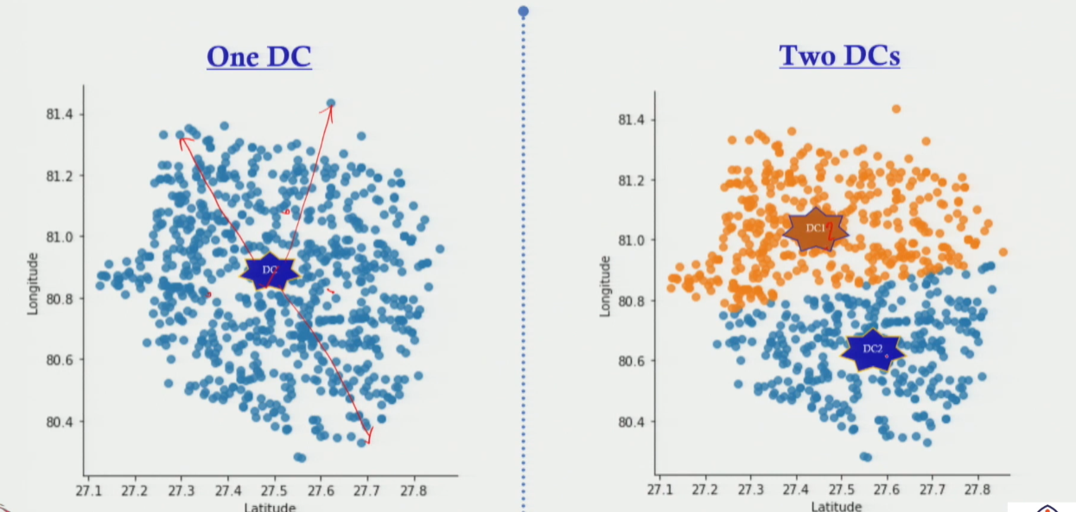
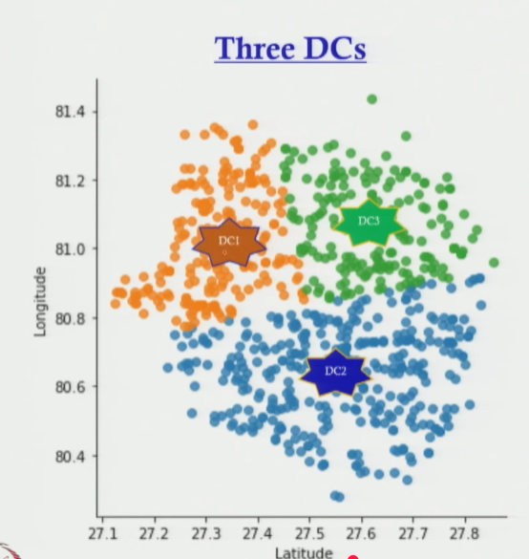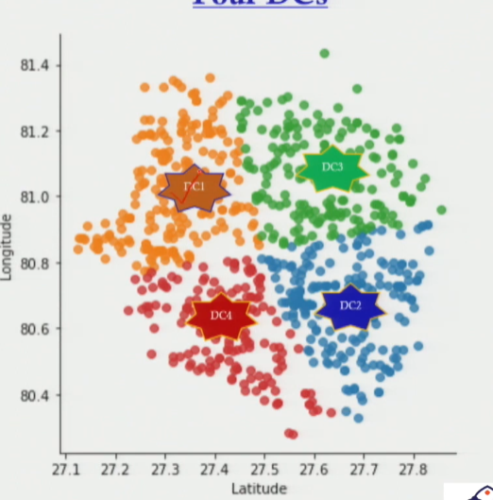
- Need to find the optimal K (represent number of clusters) — balances responsiveness with cost
- Cannot decide by intuition or visual inspection alone — need a systematic data-driven method

★ More DCs = better responsiveness BUT higher cost. The optimal K minimizes cost while maintaining acceptable service.

4. K-means Clustering — Introduction
What is K-means Clustering?
- An unsupervised machine learning technique for grouping data points into K clusters
- Input: dataset with coordinates (lat, long) + value of K (no. of clusters desired)
- Output: (1) cluster assignment for each data point, (2) centroid of each cluster
- In SC context: segments customers AND locates DCs simultaneously

K-means Concept Applied to This Case
- K = number of DCs to open (user-defined input)
- Each cluster = all customers served by one DC
- Centroid of each cluster = proposed location (lat, long) of that DC
- Example: K = 6 → 6 clusters → 6 centroids → 6 DC locations

Concept | Explanation
K (input) | Number of clusters = number of DCs to open. User defines K.
Output 1 — Segmentation | Each of 811 customers assigned to exactly 1 cluster (served by 1 DC)
Output 2 — Centroid | Center point of each cluster = proposed DC location (lat, long)
Why centroid for DC? | Distance from centroid to all cluster members is minimized — optimal service point
Optimal K? | Not pre-defined — determined using elbow method / cost analysis (covered next session)
Tool | Python code — shown in next session

5. Why is Centroid the Best DC Location?
- Centroid = geometric center of all customer coordinates in that cluster
- Distance from centroid to each cluster member is minimized on average
- Placing DC at centroid → minimum average travel distance to all assigned customers
- Result: faster delivery + lower transport cost per cluster

★ Centroid = optimal DC location within a cluster because it minimizes total distance from DC to all customers in that cluster.

6. How K-means Answers Both Decisions
Decision 1 — Customer Segmentation
- K-means automatically assigns each of 811 customers to exactly 1 cluster
- Customers in the same cluster are spatially close to each other and to their centroid
- No manual mapping needed — algorithm does it based on distance

Decision 2 — DC Location
- Centroid of each cluster gives the latitude and longitude of the proposed DC
- This is the point that minimizes average distance to all customers in that cluster
- Example with K = 3:
- DC1 = centroid of orange cluster
- DC2 = centroid of blue cluster
- DC3 = centroid of green cluster

Remaining Open Question
- K-means solves BOTH decisions for a given K — but what is the right K?
- Is K = 1, 3, 4, 5 or 6 optimal for this pharma company?
- This is answered using the Elbow Method — covered in next session
- Python code for K-means implementation also shown in next session

Session Summary
- Problem: 811 customer locations (lat/long) — where to open DCs, how to assign customers to DCs
- Tradeoff: More DCs → better responsiveness, higher cost. Optimal K balances both.
- K-means Clustering: unsupervised ML technique — groups customers into K clusters
- Output 1 — Segmentation: each customer assigned to 1 cluster (= 1 DC's service area)
- Output 2 — Centroid: center of each cluster = proposed DC location (lat, long)
- Why centroid? minimizes average distance from DC to all customers in that cluster
- Next session: K-means algorithm in detail + Elbow Method for finding optimal K + Python code

★ Exam Tip: K-means solves TWO problems at once: (1) customer segmentation and (2) DC location via centroids. State both in exam answers.
★ Exam Tip: Centroid = optimal DC location because it minimizes average travel distance within the cluster. This is the geometric justification.
★ Exam Tip: Tradeoff: More DCs → better service level (fewer customers per DC) but higher fixed + variable cost. Optimal K balances these two.

